**CHAPTER 2**

**DESIGN PROCEDURE**

* 1. DESIGN PROCEDURE OF THE WEBSITE

In this proposed project of “**The Development of a Website for CSE Jahangirnagar University**”. The proposed modules that should be contained for the design are stated hereby.

1. A home page containing the message of chairman of CSE department.
2. Full list of faculty members of CSE department with detailed information.
3. Full syllabus of the undergraduate program of CSE department.
4. Important events.
5. Notice.
6. Full list of journals of CSE department.
7. PMSCS program.
   1. TECHNOLOGIES USED FOR DESIGN AND DEVELOPMENT

To design and develop a perfect website we need to use some technologies. Some hardware and software systems are required.

* + 1. PERSONAL COMPUTER

A personal computer or PC is needed. It may be desktop or laptop. But, it should have some specifications.

Processor Specification Core i3 Speed 1.7 GHz or above

Memory Specification 2 GB (minimum)

Hard Disk Specification 100GB

Operating System Windows 7 or above

* + 1. TEXT EDITOR

Text editor is important software to design and develop web pages. Text editor is the place where programs are written to be compiled. Version 3 of Sublime Text is used in the development of this website. Sublime text is a popular text editor. It has awesome themes and other features multiple cursors system. Emmet plugin is available for sublime text which helps to auto-fill HTML code.

2.2.3 SERVER

Almost all of the work web application takes place on the server. A specific application, called a web server, will be responsible for communicating with the browser. A relational database server stores whatever information the application requires. Finally, we need a language to broker requests between the web server and database server, it will also be used to perform programmatic tasks on the information that comes to and from the web server. But of course none of this is possible without an operating system. The web server, programming language, and database server we use must work well with the operating system.

There are many web servers out there in the market. To implement exam automation system, APACHE is used, because the apache web server is the most popular web server. PHP will most often run as an apache extension, known as apache module. It is a great web server, and it is extremely fast and amazingly stable.

MYSQL has been used as database in the proposed system. It is cost-effective. It is quick and powerful. It may not have every bell and whistle available for a relational database, but for most users there is plenty.

WAMP or XAMPP server is combination of PHP, APACHE, and MYSQL server.

* + 1. SCRIPTING LANGUAGES

PHP has been used as scripting language as it is easy and fast. PHP has managed the perfect mix power, structure and easy to use. In the end, PHP offers the best opportunity to develop powerful web application quickly. The generalization made, there are other excellent reasons for choosing PHP.

* **Cross-platform:** Most PHP code can be processed without alteration on computers running many different operating systems. For example, a PHP script that runs on windows generally also runs well on Linux.
* **HTML-embedded:** PHP code can be written in files containing a mixture of PHP instructions and HTML code.
* **Server-side:** The PHP programs are run on a server, specifically a web server.
* **Web-scripting language:** PHP programs run via a web browser.

This means, programs that mix PHP code and HTML, run them on a web server, and access them from a web browser that displays the result of PHP processing by showing the HTML returned by run by the web server.

* + 1. MVC FRAMEWORK

MVC is a system where all programs are divided into three essential categories, model, view and controller. View is the part where programs are created display the design to the users. Controller controls what is to be displayed, how is to be displayed and how much is to be displayed. Model is used to create relation between data which passes across the system. Frameworks can be used to manage MVC in the system.

Laravel is one of the most popular framework for PHP web development. Laravel is capable of handling big web project. Laravel ensures security of the site and creates quality code. This website is built in laravel framework.

* 1. VIEWS OF THE WEBSITE

For MVC framework, view is the sector where all viewable graphical user interfaces are being designed. In this project, we have some proposed modules which is needed to be displayed in user interface.

* + 1. HOME PAGE

The homepage contains Jahangirnagar University logo, menu bar, a photo of Jahangirnagar University CSE department and message of the chairman. This page also has sidebars with few notice and event list.

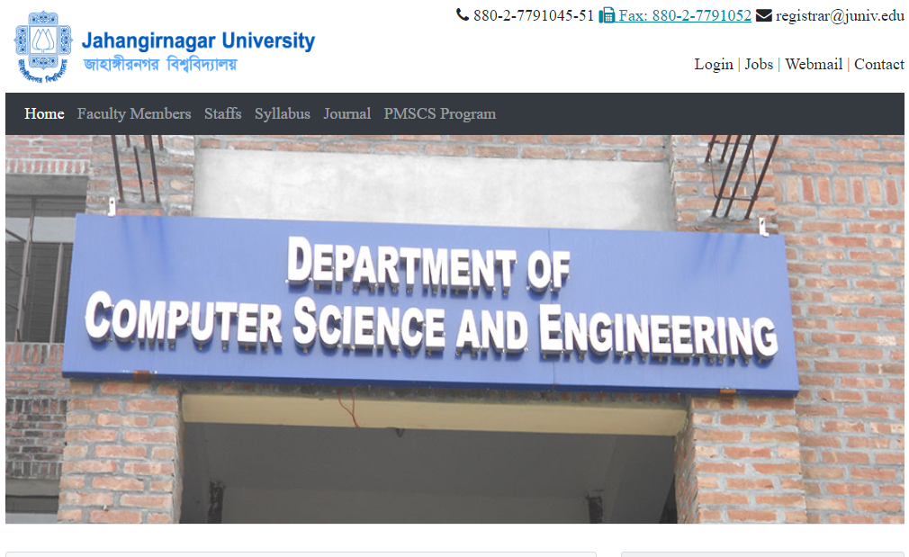

Figure 2.1: Home page of the website.

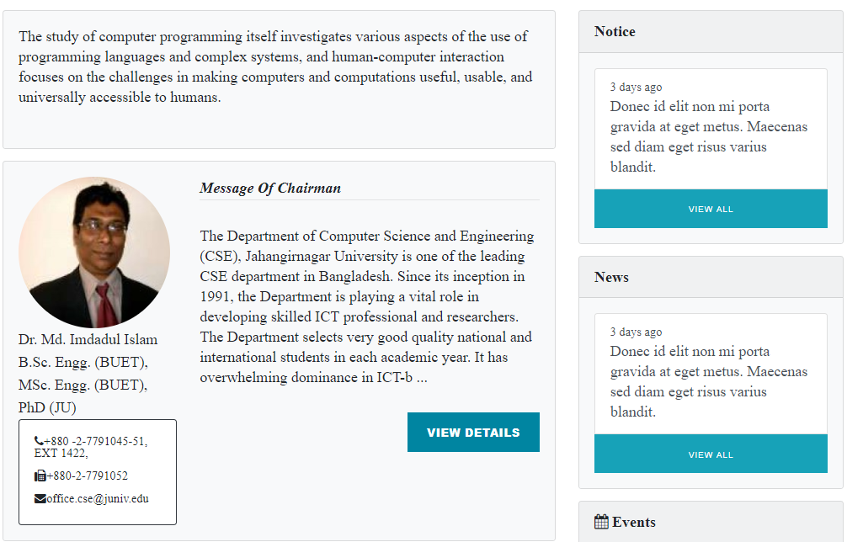

Figure 2.2: Message of chairman.

* + 1. FACULTY MEMBER LIST

The next module was to displaying a faculty member list where the list of all teachers are shown in this page and by clicking on teachers;, users can get detailed information on the teachers.

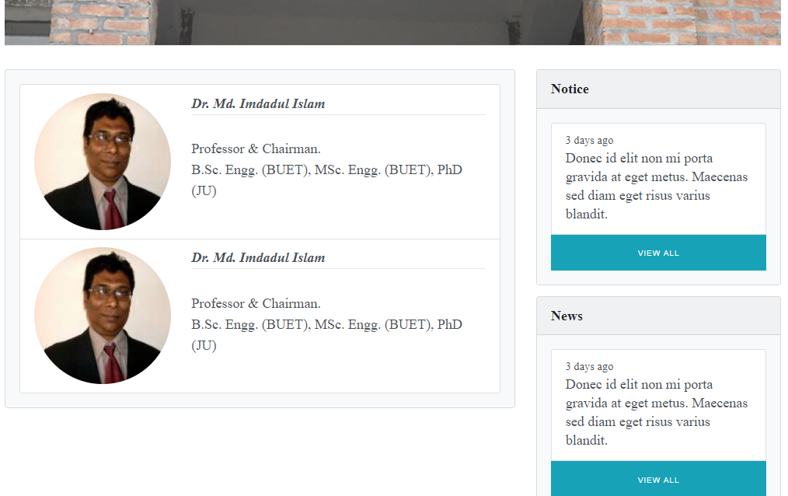

Figure 2.3: List of faculty members.

* 1. CONTROLLER OF THE WEBSITE

Controller is the section where some classes and functions are created to set program for each view. Controller joins view section and model section. Controller helps to set program of save update show or delete data. This section is also used to display a page from view.

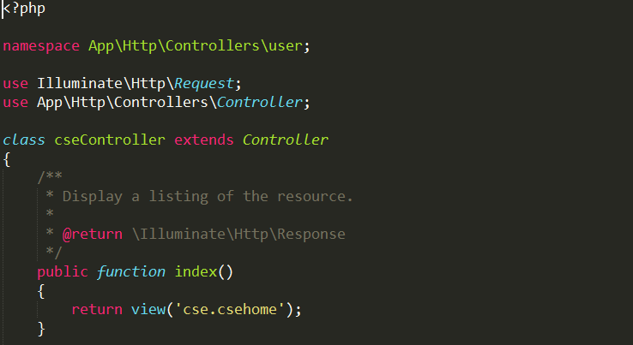

Figure2.4: index() function of cseController controller for displaying home page.

.